Monday 2nd November

Dear Parents and Carers,
We hope that your children enjoyed their half term break and that they have come back ready for another brilliant term. Over the coming weeks we will be beginning assessments and mock exams which your children will no doubt discuss with you.
We wanted to write to acknowledge the announcement that was made on Saturday evening about the second lockdown and to reassure you that we are working on any changes that we feel need to be made to the systems in school. The risk assessment was reviewed at the end of term one and this can be found on our website. We will, of course, review it again once any additional guidance is released from the government.
However, the following steps remain the same and have been reinforced with students:
- Students enter and leave through different doors.
- Students are taught in “bubbles” and remain in their Year Group zones unless they have music, art or PE.
- Students have separate areas for break time and lunch time.
- Students can wear a mask if they wish.
- Year Groups have separate toilet blocks
- There are hand-sanitiser stations outside every classroom for students to use on entering and leaving each room

It is also important to remember that students should not be sent to school if they are unwell, particularly if they have any of the following symptoms:
- Loss of taste and/ or smell
- High temperature
- A new, persistent cough

Please talk to your children about these symptoms as it is crucial that we are able to act fast around any potential contacts that students may have had.
If your child needs to isolate for any reason then please direct them to the online curriculum which can be found on our website. The link is here.
We will write to you in due course if there are any changes,
With our best wishes
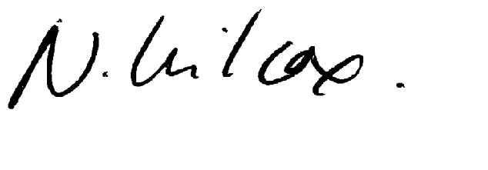
Izzy Ambrose and Natalie Wilcox

