KPI 1 – Algebra (Hegarty: 151-53, 155, 156-61 167-171, 780, 781, 221-224, 280-84)  Indices:  Multiplying Indices: Add the powers  $$a^{x}×a^{y}=a^{x+y}$$  Dividing Indices: Subtract the powers  $$\frac{a^{x}}{a^{y}}=a^{x-y}$$  Anything to the power 0: always equals 1  Indices within Brackets: Multiply the powers  $${(a^{x})}^{y}= a^{xy}$$  Key words:  Solve: work out the value of the letter  Expand: multiply out brackets 2(x+3)=2x+6  Factorise: put brackets back in x²–3x = x(x–3)  Substitution: Exchanging letters for numbers.  Changing the subject: rearranging a formula, using balancing, to make another variable the subject.  KPI 5 – Right angled triangles (497-502, 508-515)  Pythagoras:  For a right-angled triangle  $$a^{2}+b^{2}= c^{2}$$  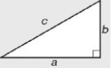  Trigonometry:  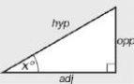  Sinx⁰ = $\frac{OPP}{HYP}$  Cosx⁰ = $\frac{ADJ}{HYP}$  Tanx⁰ = $\frac{OPP}{ADJ}$  Exact Trig Values:  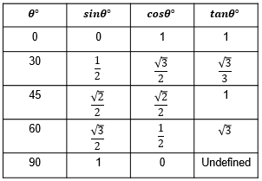 | KPI 2 – Equations, Inequalities and Sequences (176-183, 188-198, 218-220, 247, 261, 263, 264 265-72, 230, 234)  Key words:  Equation: is true for some particular value of x  Identity: is true for every value of x  Simultaneous Equations:  Linear eg 2x + 3y = 1  3x – 5y = 11  Make y terms (or x) equal  Same Signs Subtract  Different Signs Add  Solving Quadratics:  First rearrange into ax² + bx + c = 0  Factorise put into 2 brackets and one of the brackets must = 0  Sequences:  Triangular number: counts dots arranged in an equilateral triangle  Fibonacci Sequence: Each number equals the sum of the two numbers before it.0, 1,1,2,3,5,8…  Inequalities:  Using the > , < , $≤ and ≥$ | KPI 3 – Graphs (199-202, 205-214, 217)  KPI 4 – Quadratic graphs (251-55, 257, 298-301)  Types of graph:  Straight Line Graphs  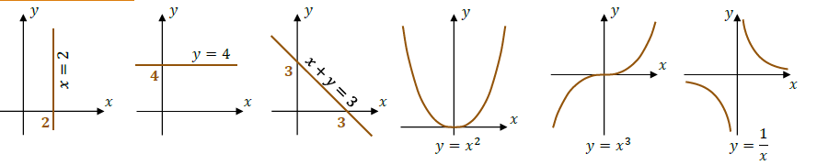  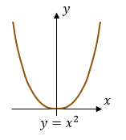  Quadratic Graph  Cubic Graph  Reciprocal Graph  Equation of straight line graphs:  Equation of a Straight line:  y = mx + c  M is the gradient, c is the y  Intercept  Gradient: $\frac{Change in y}{Change in x}$  To find the midpoint between:  ($x_{1}$, $y_{1}$) and ($x_{2}$, $y_{2}$) use the formula:  $$(\frac{x_{1}+x_{2}}{2},\frac{y_{1}+y_{2}}{2})$$

