Topic 1 – Number (Hegarty 29 – 35, 56, 99 – 108, 111, 115, 118, 119, 121, 130, 131, 135, 173)  Key Words:  HCF/ LCM:  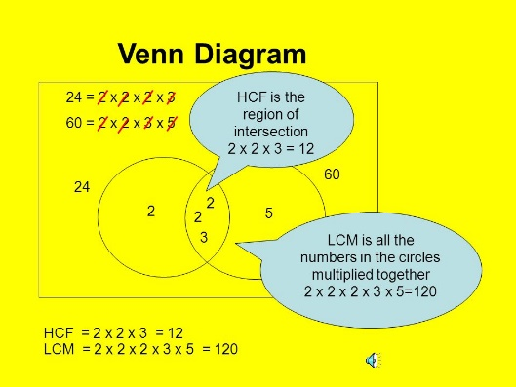 | Topic 1 – Continued  Standard Form  Standard form numbers are of the form $a×{10}^{n}, where 1≤a<10$ and $n$ is an integer.  Index Laws  The Rules of Surds (Higher Only)  - $\sqrt{a}$ x $\sqrt{b}$ = $\sqrt{ab}$  - $\frac{\sqrt{a}}{\sqrt{b}}$ = $\sqrt{\frac{a}{b}}$  - $\sqrt{a } x \sqrt{a}=a$  - 4$\sqrt{a}$ + 5$\sqrt{a}$ = 9 $\sqrt{a}$  - $\sqrt{a}+ \sqrt{b}$ = does not simplify | Topic 2 – Fractions and Percentages (Hegarty 48, 52, 60, 65-70, 73, 77, 78, 80 – 87, 90, 93, 98)  Fraction is numerator ÷ denominator  - $\frac{5}{8}=5÷8=0.625$  Use place values to change decimals to fractions. Simplify where possible.  $0.45=\frac{45}{100}=\frac{9}{20}$  Learn the most frequently used ones:  Adding or subtracting fractions; use a common denominator…  - $\frac{4}{5}-\frac{1}{3}=\frac{12}{15}-\frac{5}{15}=\frac{7}{15}$  Multiplying fractions; multiply numerators and denominators…  $\frac{4}{7}×\frac{2}{3}=\frac{8}{21}$  Dividing fractions; “flip” the second fraction, then multiply…  $\frac{2}{7}÷\frac{5}{6}=\frac{2}{7}×\frac{6}{5}=\frac{12}{35}$  Percentages  Percentage change = $\frac{Amount of change}{Original Amount} x 100$  Compound Interest (Higher only)  $$New Value=P {(1+ \frac{R}{100})}^{n}$$  P is the initial principal sum of money  R is the interest rate in percentage  n is the time period in years
  Key word | Definition | Example
  Integer | A whole number | -5, -2, 0, 1 , 2 etc
  Factors | The divisors of an integer | Factors of 12 are 1,2,3,4,6,12
  Multiples | A “times table” for an integer | Multiples of 12 are 12, 24, 36…
  Prime Factor | Factors of a number that are also prime (found using a factor tree) | Prime factor of 24 = 2 x 2 x 2 x 3  (2³ x 3)
  Prime Numbers | 2, 3, 5, 7, 9, 11, 13, 17, 19
  Square Numbers | 1, 4, 9, 16, 25, 36, 49, 64,81,100,121,144
  Cube Numbers | 1, 8, 27, 64, 125
  Multiplying | $$y^{a} x y^{b} = y^{a+b}$$
  Dividing | $$y^{a} ÷y^{b}= y^{a-b}$$
  Raising the power | $${(y^{a})}^{b}= y^{ab}$$
  Power of zero | $y^{0}$ = 1
  Negative indices | $$y^{-a }= \frac{1}{y^{a}}$$
  Fractional indices | $$y^{\frac{a}{b}}= \sqrt[b]{y^{a}}$$
  Square root is the same as power of $\frac{1}{2}$ | $\sqrt{y}$ = $y^{\frac{1}{2}}$
  $$\frac{1}{2}$$ | $$\frac{1}{4}$$ | $$\frac{1}{10}$$ | $$\frac{1}{5}$$ | $$\frac{3}{4}$$
  0.5 | 0.25 | 0.1 | 0.2 | 0.75
  50% | 25% | 10% | 20% | 75%
Topic 3 – Ratio and Proportion (Hegarty 325, 328, 331 – 341)  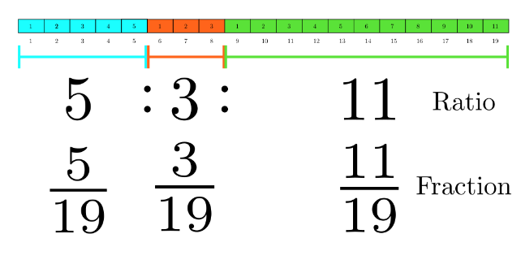  Notation and relationship with fractions (denominator is found by adding all parts of the ratio together) | Scatter Graphs  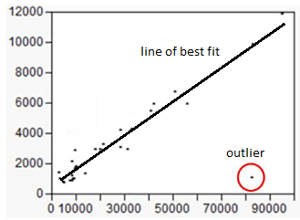Positive Negative  correlation correlation  Pie Charts  Angle of a sector = $\frac{Frequency of Data}{Total Frequency} x 360$  Averages  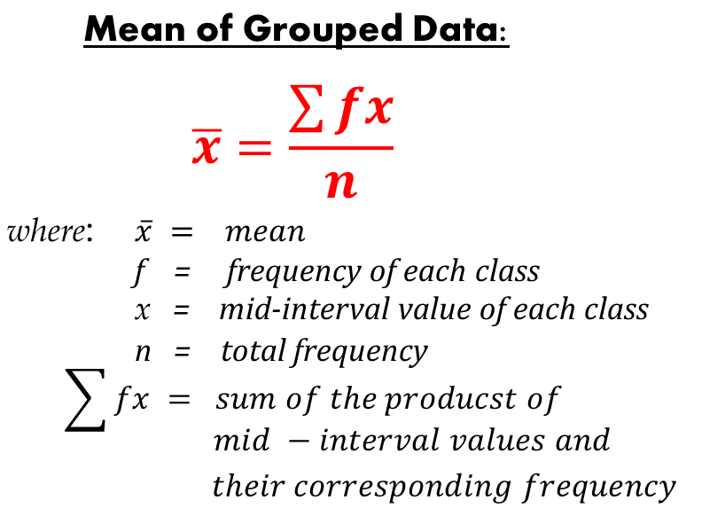  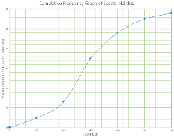  Cumulative Frequency (Higher Only)  Cumulative frequency – a running total of frequencies, plotted as points at the upper bound of the group and drawn as a curve.  Box Plots (Higher only)  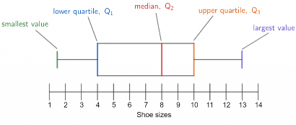  Median – half way through the data  LQ - a quarter of the way through the data  UQ – three quarters of the way through the data  Interquartile range = UQ – LQ
  Range | Difference between the largest and smallest values
  Mode | Most frequently occurring
  Median | Put the data in numerical order and then choose the middle one
  Mean | $$\frac{Total of all items of data}{Number of items of data}$$
  Modal Class | The class (group) with the highest frequency
Topic 4 – Interpreting Data (Hegarty 395-6, 403, 418, 422, 430 – 438, 450 – 454)
Stem and Leaf diagrams


