Operations with Integers and Decimals -  (Hegarty 13-16, 18-20, 45, 46)  Order of Operations - (Hegarty 24 & 120)  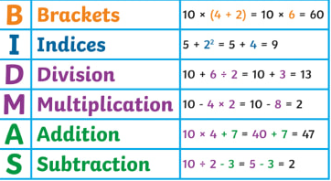 | Rounding - (Hegarty 17, 56, 130)  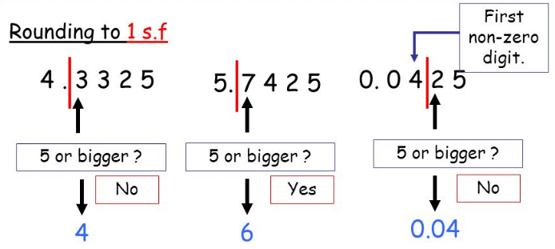  Powers roots and index laws - (Hegarty 99 – 103)  2⁵ = 2 x 2 x 2 x 2 x 2 = 32  Prime Factor Decomposition - (Hegarty 29,30)  48 as a product of its prime factors:  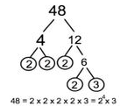 | 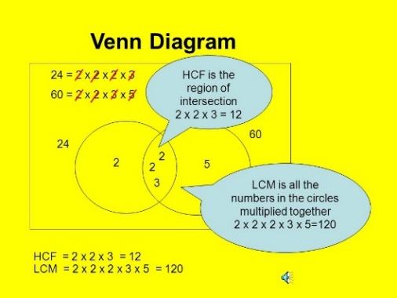  HCF & LCM - (Hegarty 31 – 35)  Fractions - (Hegarty 57-72)  Fraction is numerator ÷ denominator  - $\frac{5}{8}=5÷8=0.625$  Use place values to change decimals to fractions. Simplify where possible.  $0.45=\frac{45}{100}=\frac{9}{20}$  Learn the most frequently used ones:  Adding or subtracting fractions; use a common denominator…  - $\frac{4}{5}-\frac{1}{3}=\frac{12}{15}-\frac{5}{15}=\frac{7}{15}$  Multiplying fractions; multiply numerators and denominators…  $\frac{4}{7}×\frac{2}{3}=\frac{8}{21}$  Dividing fractions; “flip” the second fraction, then multiply…  $\frac{2}{7}÷\frac{5}{6}=\frac{2}{7}×\frac{6}{5}=\frac{12}{35}$
  Prime Numbers | 2, 3, 5, 7,11, 13, 17, 19
  Square Numbers | 1, 4, 9, 16, 25, 36, 49, 64,81,100,121,144, 169, 196, 225
  Cube Numbers | 1, 8, 27, 64, 125
  Multiplying | $$y^{a} x y^{b} = y^{a+b}$$
  Dividing | $$y^{a} ÷y^{b}= y^{a-b}$$
  Raising the power | $${(y^{a})}^{b}= y^{ab}$$
  Power of zero | $y^{0}$ = 1
  Square root | $$\sqrt[2]{}$$
  Cube root | $$\sqrt[3]{}$$
  $$\frac{1}{2}$$ | $$\frac{1}{4}$$ | $$\frac{1}{10}$$ | $$\frac{1}{5}$$ | $$\frac{3}{4}$$
  0.5 | 0.25 | 0.1 | 0.2 | 0.75
  50% | 25% | 10% | 20% | 75%
Inequalities & Negative Numbers –
(Hegarty 37-44)
> Greater than
≥ Greater than or equal to
< Less than
≤ Less than or equal to
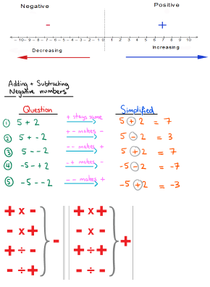
≠ Not equal to
= Equals

Perimeter and Area - (Hegarty 548,549, 553-559)  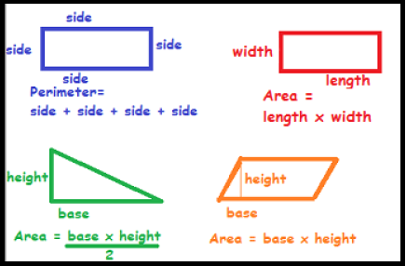  Area of a Trapezium  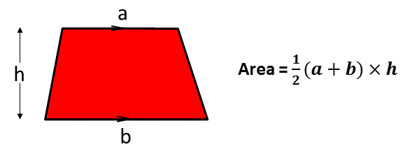  Time - (Hegarty 709)  Station Departure Arrival  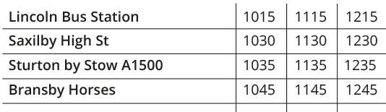 | Circles - (Hegarty 534, 539, 592)  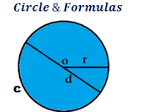  Area of a circle = $πr^{2}$  Circumference of a circle = $πd$ or $2πr$  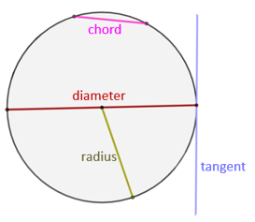  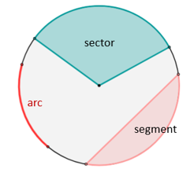 |  | Measure - (Hegarty 716, 725, 691-693)  1cm = 10mm  1m = 100cm  1km = 1000m  1kg = 1000g  1 litre = 1000cm³  $$speed=\frac{distance}{time} \\ density=\frac{mass}{volume}$$

