Achieving Success: Revision timetable
Name:
Yate Academy

Problem | Your mentor will:
How to revise successfully | Go through the types of revision you should be doing and how it will best suit you. Page 19
How to make a revision timetable | Go through how to use the monthly and weekly calendar to form a revision timetable. 3
How to reduce stress | Page 20, 21
How to revise in lessons | Page 22
Not sure of my bigger plan | Refer you to the careers advisor – contact Mrs Lewis
Other | Please let Mrs Lewis know if you would like help on other areas that are identified.

Need a helping hand? Just ask any member of staff and they will be happy to help you or point you in the right direction

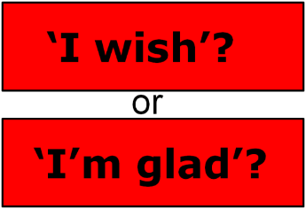
Making a weekly and/or monthly timetable
Building a revision timetable can add structure to your revision and help you identify which GCSE subjects you need to prioritise to get better marks.
Creating a revision timetable is a great way to organise your study time, plus it also helps boost your motivation to revise for your exams. Recognising a need for a revision timetable means that you have already made a great start to combat stress. Take the first step by setting your GCSE study goals to build a strong foundation for success.
Better time management skills improve your academic performance and keep your stress levels under control. Prioritise, Planning, and Persistence are the three P’s of effective time management skills.
Prioritise- learn to say ‘NO’ to your friends so that you can keep to your schedule. A short-term shift in your lifestyle might be needed to help you accomplish your goals.
Planning- find a balance between study and free time. Put time aside for both by making and revising a study timetable that works for you. Get studying over and done with first so you can really switch off and enjoy your free time.
Persistence- having persistence is the ability to beat laziness and sticking to your study timetable. Avoidance of doing a task which needs to be accomplished can create stress.
Planning to Study: Deciding what is to be done?
Making the most of the time available is a skill and like so many other skills it can be learned. Ask yourself......’ What is important?’ and ‘What is urgent?’
You will have commitments in your life that require time dedicated to them. Some commitments are incredibly important to you and occur at a fixed time in the week and cannot be rescheduled put these into your schedule. Be specific on your plan.
You will need to not just write down the subject you are going to study but what exactly you will be doing in that subject in the time you have allocated yourself. For example, if you are going to do some physics – which section are you going to look at? How are you going to go over the section? Are you going to make resources in that period or learn from resources you have already made? If you have a work book which pages are you
going to do? Use your QLA or feedback from your subjects to learn the areas you are not successful in yet don’t spend time on the things you know

Mon | Tue | Wed | Thu | Fri | Sat | Sun
 |  |  | 1 | 2 | 3 | 4
5 | 6 | 7 | 8 | 9 | 10 | 11
12 | 13 | 14 | 15 | 16 | 17 | 18
19 | 20 | 21 | 22 | 23 | 24 | 25
26 | 27 | 28
February 2018

Mon | Tue | Wed | Thu | Fri | Sat | Sun
 |  |  | 1 | 2 | 3 | 4
5 | 6 | 7 | 8 | 9 | 10 | 11
12 | 13 | 14 | 15 | 16 | 17 | 18
19 | 20 | 21 | 22 | 23 | 24 | 25
26 | 27 | 28 | 29 | 30 | 31
March 2018

April 2018

Mon | Tue | Wed | Thu | Fri | Sat | Sun
Revision sessions Planned: |  |  |  |  |  | 1
2 | 3 | 4 | 5 | 6 | 7 | 8
9 | 10 | 11 | 12 | 13 | 14 | 15
16 | 17 | 18 | 19 | 20 | 21 | 22
23 | 24 | 25 | 26 | 27 | 28 | 29/30
May 2018

Mon | Tue | Wed | Thu | Fri | Sat | Sun
 | 1 | 2 | 3 | 4 | 5 | 6
7 | 8 | 9 | 10 | 11 | 12 | 13
14 | 15 | 16 | 17 | 18 | 19 | 20
21 | 22 | 23 | 24 | 25 | 26 | 27
28 | 29 | 30 | 31

June 2018

Mon | Tue | Wed | Thu | Fri | Sat | Sun
 |  |  |  | 1 | 2 | 3
4 | 5 | 6 | 7 | 8 | 9 | 10
11 | 12 | 13 | 14 | 15 | 16 | 17
18 | 19 | 20 | 21 | 22 | 23 | 24
25 | 26 | 27 | 28 | 29 | 30

Monday | Tuesday | Wednesday | Thursday | Friday | Saturday | Sunday
9.00
10.00
11.00
12.00
1.00
2.00
3.00
4.00
5.00
6.00
7.00
8.00
9.00
10.00

Monday | Tuesday | Wednesday | Thursday | Friday | Saturday | Sunday
9.00
10.00
11.00
12.00
1.00
2.00
3.00
4.00
5.00
6.00
7.00
8.00
9.00
10.00

Monday | Tuesday | Wednesday | Thursday | Friday | Saturday | Sunday
9.00
10.00
11.00
12.00
1.00
2.00
3.00
4.00
5.00
6.00
7.00
8.00
9.00
10.00

Monday | Tuesday | Wednesday | Thursday | Friday | Saturday | Sunday
9.00
10.00
11.00
12.00
1.00
2.00
3.00
4.00
5.00
6.00
7.00
8.00
9.00
10.00

Monday | Tuesday | Wednesday | Thursday | Friday | Saturday | Sunday
9.00
10.00
11.00
12.00
1.00
2.00
3.00
4.00
5.00
6.00
7.00
8.00
9.00
10.00
 | Tuesday | Wednesday | Thursday | Friday | Saturday | Sunday
9.00
10.00
11.00
12.00
1.00
2.00
3.00
4.00
5.00
6.00
7.00
8.00
9.00
10.00

Monday | Tuesday | Wednesday | Thursday | Friday | Saturday | Sunday
9.00
10.00
11.00
12.00
1.00
2.00
3.00
4.00
5.00
6.00
7.00
8.00
9.00
10.00

Monday | Tuesday | Wednesday | Thursday | Friday | Saturday | Sunday
9.00
10.00
11.00
12.00
1.00
2.00
3.00
4.00
5.00
6.00
7.00
8.00
9.00
10.00

Monday | Tuesday | Wednesday | Thursday | Friday | Saturday | Sunday
9.00
10.00
11.00
12.00
1.00
2.00
3.00
4.00
5.00
6.00
7.00
8.00
9.00
10.00

Monday | Tuesday | Wednesday | Thursday | Friday | Saturday | Sunday
9.00
10.00
11.00
12.00
1.00
2.00
3.00
4.00
5.00
6.00
7.00
8.00
9.00
10.00

How to revise successfully
There are many ways of revising but some are more beneficial than others.
You will need to try them all to find out which one is best for you.
You may find that the one way you like best doesn’t always give you the best results for example making flash cards or mind maps can be therapeutic but they can be time consuming and it can be difficult to assess what you have learnt from them
From research these are the best ways of getting information stuck in your brain are the ones in red.
How will you get resources to try the red ones out?
Subject and where to get exam questions
Activity | Type | Always | Sometimes | Never
Reading through class notes | C
Using resources on the school’s VLE/ other websites | C
Using course textbooks | C
Mind-maps/ diagrams | C
Writing/ re-writing class notes | C
Highlighting/ colour-coding | C
Flash cards | C
Using a revision wall to display your learning | C
Writing exam answers under timed conditions | S
Reading model answers | S
Using past exam questions and planning answers | S
Marking your own work to a mark scheme | F
Studying mark schemes or examiners reports | F
Working with other students in groups/ pairs | F
Comparing model answers against your own work | F
Creating your own exam questions | F
Handing in extra exam work for marking | F
One-to-one discussions with teachers | F
Stress Management
Stress is a condition experienced when a person feels that the demands place upon them are greater that what they can achieve. Stress can reduce your ability to cope and you no longer function effectively. However, stress does not always have a negative effect, it depends on your time management and the way you handle it. Prioritise, Planning, and Persistence.
Affects of Being Overstressed
• Damages the immune system meaning you catch more colds • Sleeping patterns will be disrupted • You will lose your appetite and stop eating properly • Fear for the future
• Become too self-critical • Doubt your abilities and expect failure • Mental performance is reduced
Negative thinking damages confidence, harms performance and paralyzes mental skills. Challenge your negative thoughts. Be positive
Relaxation Techniques
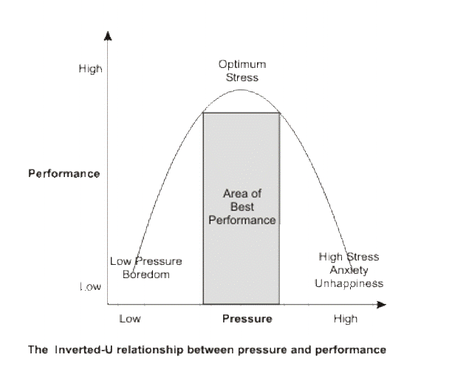
Controlled Breathing- inhale and hold for a total of 6 seconds, exhale continuously for 6 seconds. Repeat for 1 minute to get rid of any stale air held in the lungs.
Meditation- close your eyes firmly for 3 seconds before releasing for 3 seconds. Repeat twice and try to clear your head of all thoughts. Sit with eyes closed for two minutes.
Progressive Muscle Relaxation- tense various groups of muscles one at a time (e.g. quadriceps), starting with a gentle contraction, and build up to a full contraction for a total of 6 seconds before releasing.
Mental Imagery- close your eyes and imagine the exam scene. Start your mental rehearsal from the moment you wake up on the morning of your first exam. Picture how everything should be and imagine how you would like it to be.
Stress Management
Try out all of the techniques explained above and discover if any work for you. If one or more techniques work, then use them every time you feel things are getting too much for you.
Remember the best way to avoid stress is by staying on top of tasks. Do not let tasks build up as no matter how hard you try to forget about them, they will always on the back of your mind.
Healthy Body = Healthy Mind
When you are stressed, hormones are secreted which can cause high blood pressure. Use up your stress hormones with physical activity.
Regular exercise also strengthens your heart and increases the blood supply to your brain. To function most effectively, include some physical exercise in your daily routine.
List examples of things you do each week that is considered physical activity e.g. walking the dog

Look back at your Personal Study Programme and make sure you have made some time available for exercise to enable you to cope with stress. It is important to dedicate time to exercise, therefore add some of the physical activities listed above in your study programme.

How to revise in lessons

Cut down making resources by using your time in lessons wisely.
Bring revision cards in with you to the lesson or a revision notebook to use while you are in the class. (revision cards are available form Mrs Lewis if you need some.)
In some subjects w
here you are learning facts – make revision cards as you go along rather than writing the facts in your book.
When answering exam questions make a revision card with the question on the front and answer on the back – these are key to gaining marks in the exam and much quicker than learning the revision guide.
Write down quotes as you go along in a notebook so they are all in one place.
Ask your teacher what resources you could make as you are going along.
Make a note of things you don’t understand so you can as in a lesson later or in an intervention session
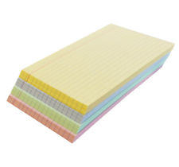Do some of your self-quizzing from the questions you get at the start of lessons if you didn’t get them right - you will need to ask the teacher for time to do this.
Make sure you ask for advice if you do not get what you are learning the first time.
Make sure you use all the time available to practice, note model answers etc.

Self-quizzing in and out of lessons
Make this part of your revision.
Use your knowledge Organiser to make your questions based on facts you did not know and spend time learning the answers. The planners are designed to let you do this – you should read the questions with your planner folded so you cannot see the answers
You can use questions from your revision guide and get someone to check the answers for you.
Try and answer the questions out loud
Check to see what you got right by unfolding the planner.

Good luck - we are with you every step of the way

